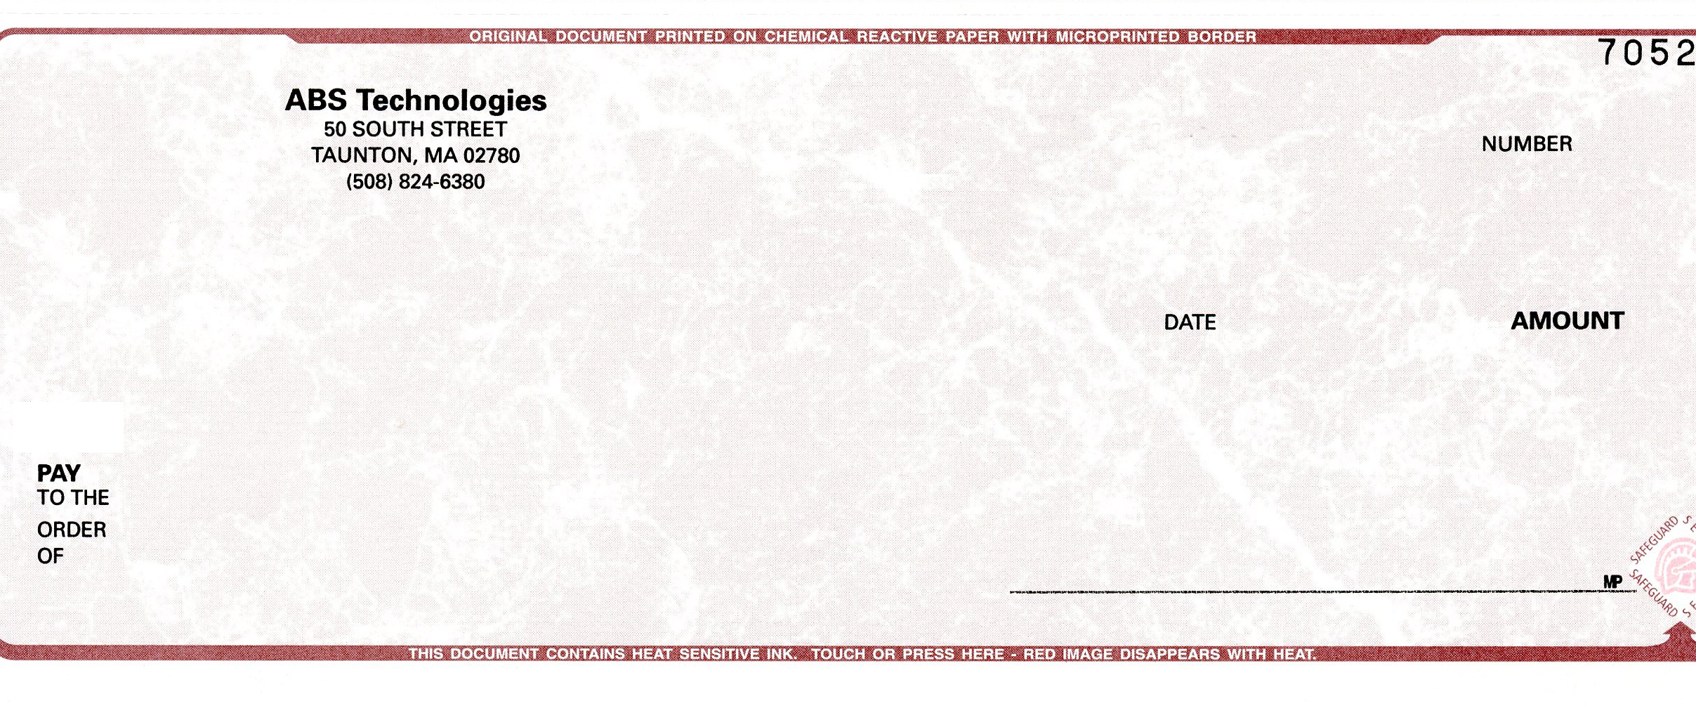
January 1, 2012
Mr. and Mrs. Daniel Gouveia
7 Billings Street
Taunton, MA 02780
Insert Your Name Here
Insert Your Address Here
Insert Town/City, State, Zip
Ten Dollars 00/100 **************************************************** $10.00
Elaine D. Costanzo President/CFO
INTRODUCING “REFER A FRIEND” PROGRAM
ONLY AT ABS TECHNOLOGIES
Here’s How It Works
- Refer a friend or family member to ABS Technologies and if they purchase any of our products and/or services, we will send YOU a check for $10 for each referral.
- Give this letter to any friend or family member for your referral. Make certain they include the PROMO CODE below with their purchase of any of our products and/or services. This will identify you as the referral friend to receive a check.
- There is no limit to the number of referrals you can provide. Simply photocopy this letter and give it to your friends and family. Before long, you may receive several referral checks from ABS Technologies.
- We are confident you know many who are interested in transferring film, tape, and slides to DVD to preserve family memories for future generations. Your DVD can also include background music with an on-screen menu to choose from. Other services include: CD and DVD duplication with full-color thermal on-disc imaging, Digital photography and wedding video services, Web hosting, Web development, streaming media online services, video biography and full production services, hardware repair, and software product sales!
- Have your referral contact ABS Technologies Customer Service Representatives anytime from 9 AM to 9 PM, Monday through Friday at 1-877-888-8894, and be sure to let them know you are part of our new “Refer A Friend” Program!

50 South Street
Taunton, MA 02780
www.absTechnologies.net
1-877-888-8894
PROMO CODE: 777

